TCI SAP S/4 HANA Implementation

Technical Specification

Parts Availability – UI – XSA Document

Version : 1.0
Date Created : 01-08-2019

Author : Gunasekhar Reddy

Document Information

GAP/CR ID

FS Definition Form ID

Type of development | UI5
SAP R/3 Version | S/4HANA ON PREMISE 1709

Approval

Approved by | Name | Role | Signature | Date
Process Team Lead
Development Team Lead
TCI System Analyst

Document History

Version | Author | Reason for change | Date
1.0 | Gunasekhar Reddy | Initial draft | 01.08.2019
1.1
1.2
1.3

Related Documents
<Reference document name and location link>
Table of Contents

1. General Information 4
2. Description and Purpose 4
3. Assumptions 5
4. Issues 5
5. Dependencies 5
6. Technical Details 5
7. Models Details 9
8. Views Details 9
9. View Controllers Details 9
10. Fragments Details 12
11. Component JS Details 12
12. Formatters Details 12
13. Patterns Details 12
14. ODATA-Gateway (Back-end) 12
15. Data Source consideration 13
16. Data Validation 14
17. Error Handling 14
18. Security Requirements/ Authorization Details 14
19. Additional Information and attachments 15
20. HANA Artifacts 16
21. Unit Test Plan 18

General Information

WRICEF ID
Description | Parts Availability
Implementation Phase | Wave 2
Transaction(s) (if applicable) | N/A
Package | ZFIORI
Message Class (if applicable)
Develop. Class
Module | XSA, UI, HANA 2.0
Enhancement User/User Group
Run Frequency |  | Language | English & French

GIT Information

Sr.No # | Branch Name | User id | Description
1 |  | Gunasekhar_reddy2@toyota.ca | https://git.ca1.hana.ondemand.com/plugins/gitiles/d36z7bqhz1%2Fpartsavailabilityweb  Parts Availability

Description and Purpose
Toyota Canada Inc. (TCI) has embarked upon a project to refresh its existing mainframe vehicle system using SAP. Multiple existing functionality present in different applications are consolidated into one application. The following functionalities are included in the Parts Availability application.

Parts Availability: The dealer is provided with an option to check the parts availability and pricing information for the dealer type. This is an important requirement for the dealers to be able to find the parts quickly and less effortlessly and so the material suggestions are provided to the dealer.

Assumptions
Dual Dealer will use respective portal to check the respective parts. Toyota for Toyota parts and Lexus for Lexus parts.

Issues
N/A

Issue # | Date Raised |  | Issue Description | Issue Resolution

Dependencies

Technical Details
  - Application Name: Parts Availability
  - Type: XSA Multi Target Application
  - Latest Version: 1.0.0
  - UI5 Libraries: sap.ui.layout, sap.ui.core, sap.ushell, sap.m
  - Components: Device, Model, Dialog, Text, Filter, History, MessageBox

  - Screens: Home Screen
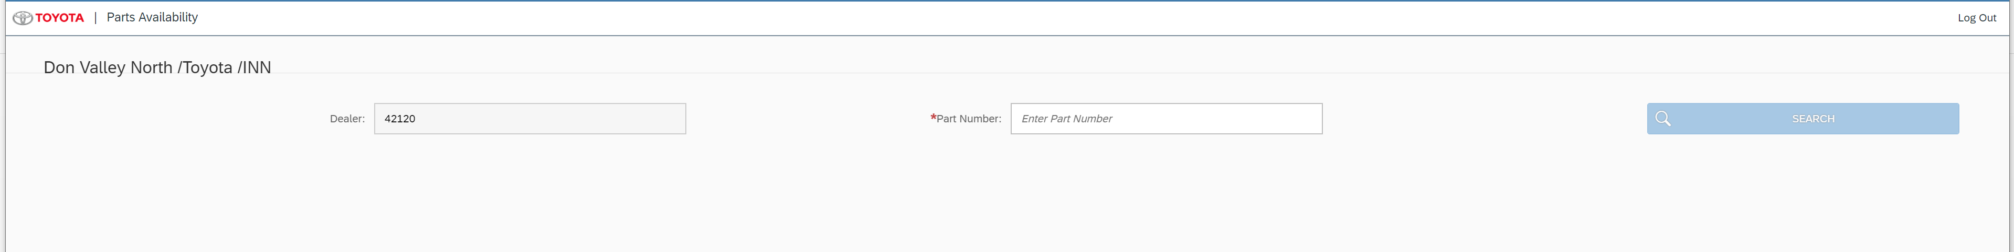

Parts Availability Material Suggestion Screen

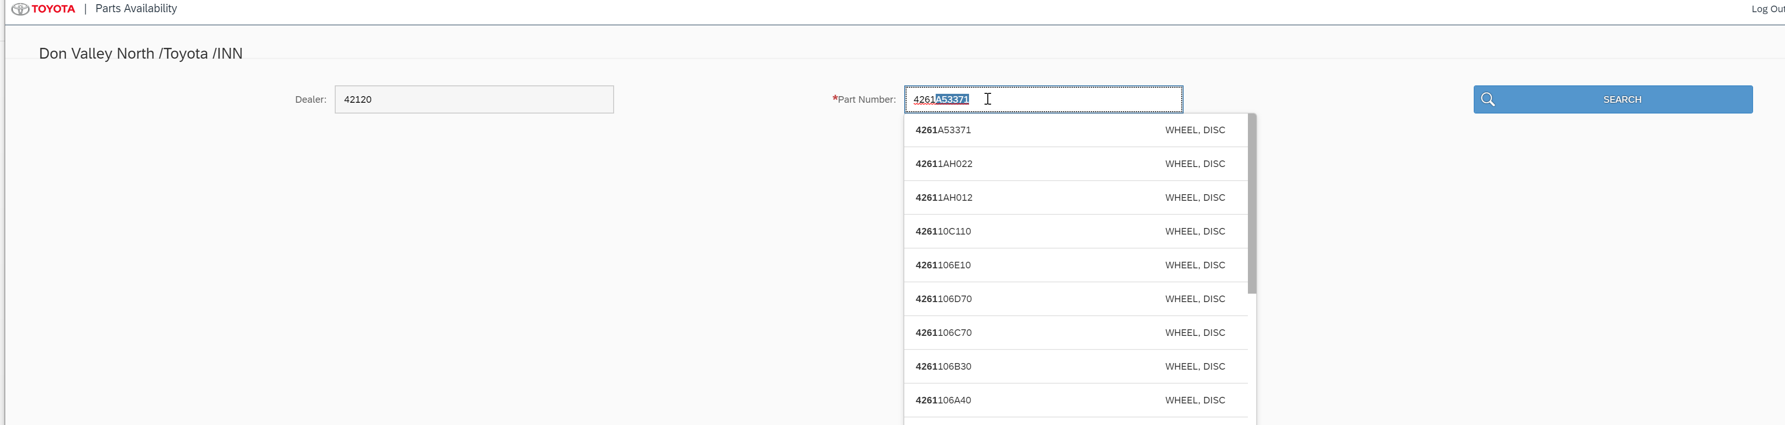

If the part is found and available in S/4 forward suggestion and supersession display.

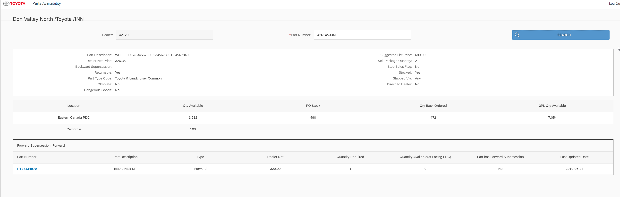

Navigating to the Supersession Material
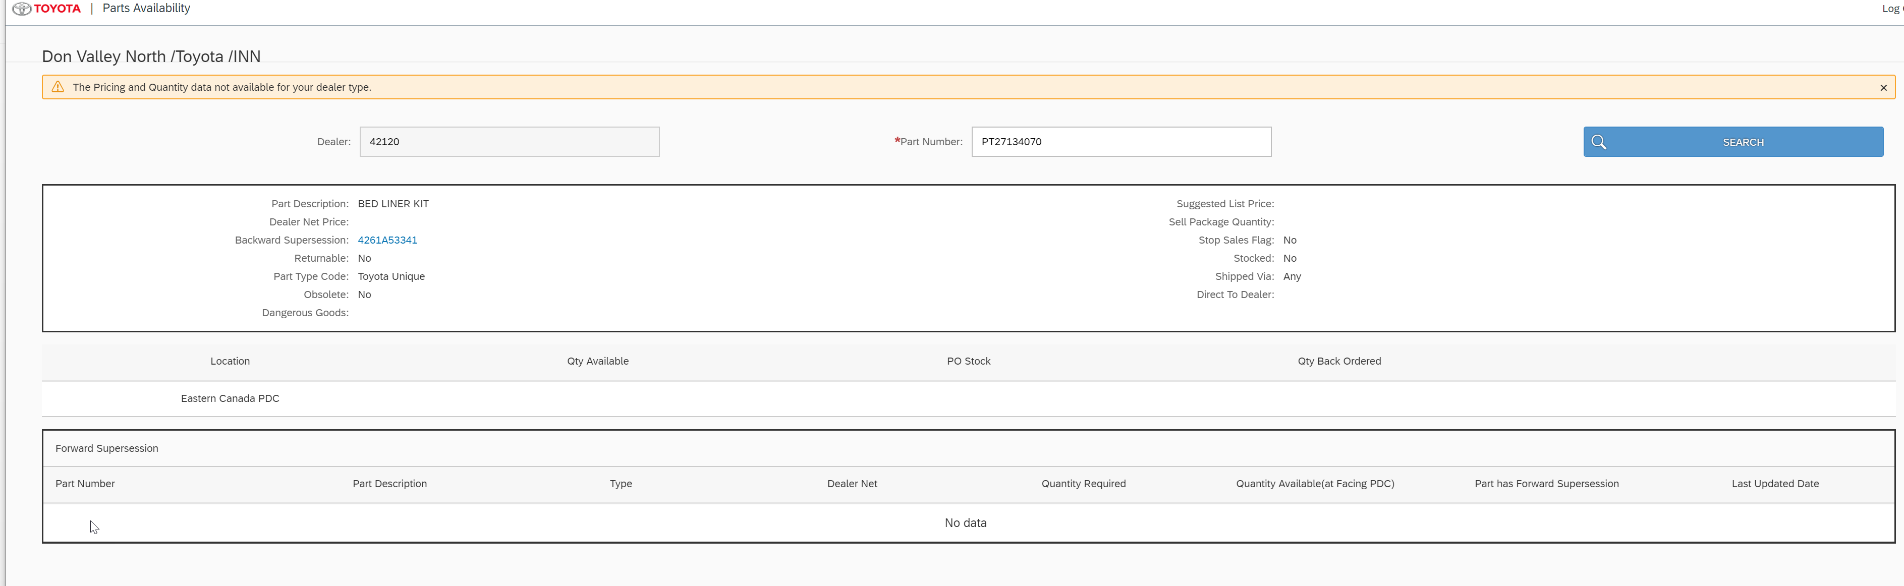

Models Details
  - Default Model
→Type: sap.ui.model.odata.v2.ODataModel
→DataSource: ZMD_PRODUCT_FS_V2_SRV

  - i18n
→Type: sap.ui.model.resource.ResourceModel
→BundleName: “i18n.i18n”

  - JSONModel
→Type: sap.ui.model.json.JSONModel

Views Details
There is only one view, searchMaterialand Display view, using the standard SAP UI5 controls and properties.

The initial view of parts Available will just accept the dealer login ID and password and an API call will be made in the node layer to check the dealer availability in S/4 System.
UAA service will authenticate and pass the Token to XSA on the type of user logged in and scopes the user id has.
The node module inturn will read this details and based on the usertype will make the appropriate api call.

For Dealer Type: the Call to API_BUSINESS_PARTNER to fetch the data is as below.

/API_BUSINESS_PARTNER/A_BusinessPartner?sap-client=" + s4Client + "&$format=json&$filter=SearchTerm2 eq '" +
dealerCode + "'&$expand=to_Customer";

For internal User: the Call to API_BUSINESS_PARTNER to fetch the dealer details are as below.

/API_BUSINESS_PARTNER/A_BusinessPartner?sap-client=" + s4Client + "&$format=json" + "&$expand=to_Customer/to_CustomerSalesArea&$filter=(BusinessPartnerType eq 'Z001' or BusinessPartnerType eq 'Z004')" +
"and zstatus ne 'X' &$orderby=BusinessPartner asc &$select=BusinessPartner,BusinessPartnerName,BusinessPartnerType,OrganizationBPName1,SearchTerm2,to_Customer/Attribute1,to_Customer/to_CustomerSalesArea/SalesOffice,to_Customer/to_CustomerSalesArea/Customer,to_Customer/to_CustomerSalesArea/SalesOrganization,to_Customer/to_CustomerSalesArea/DistributionChannel,to_Customer/to_CustomerSalesArea/Division,to_Customer/to_CustomerSalesArea/SalesGroup";

For a national User: The Call to API_BUSINESS_Partner is same as above. However, for the zone users after fetching the dealers, the zone code received from the saml is validated against the sales office and only the dealers belonging to that particular zone are returned.

The screen at this time should look like the below.

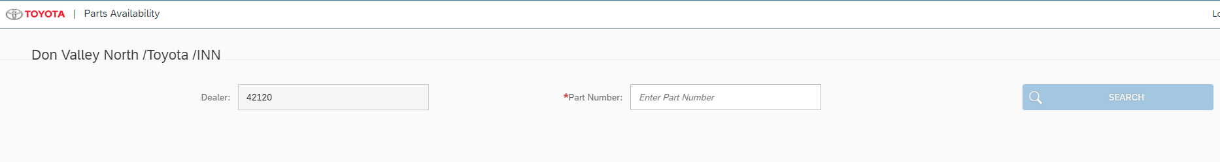

For internal user the Dealer drop down is a combobox with valid dealers.

Part number is the only editable field for now and the search box is non actionable without part number.

The part number is a suggestion list which starts after receiving the first 3 characters,

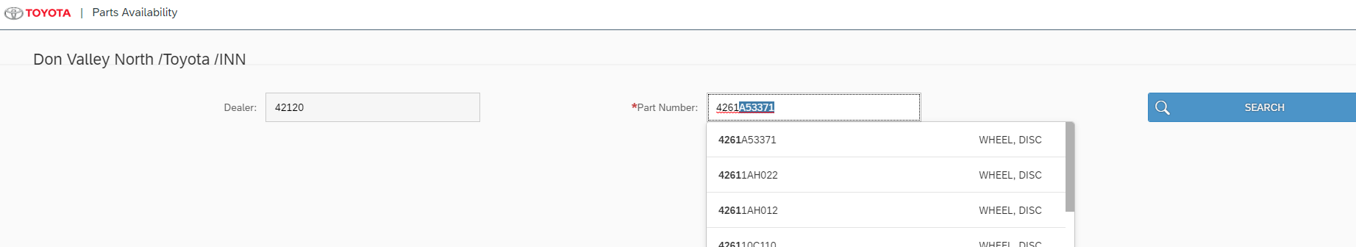

Please view the Suggestion Details in the controller section for the corresponding logic.

The selected material from the screen is used to make API Calls,
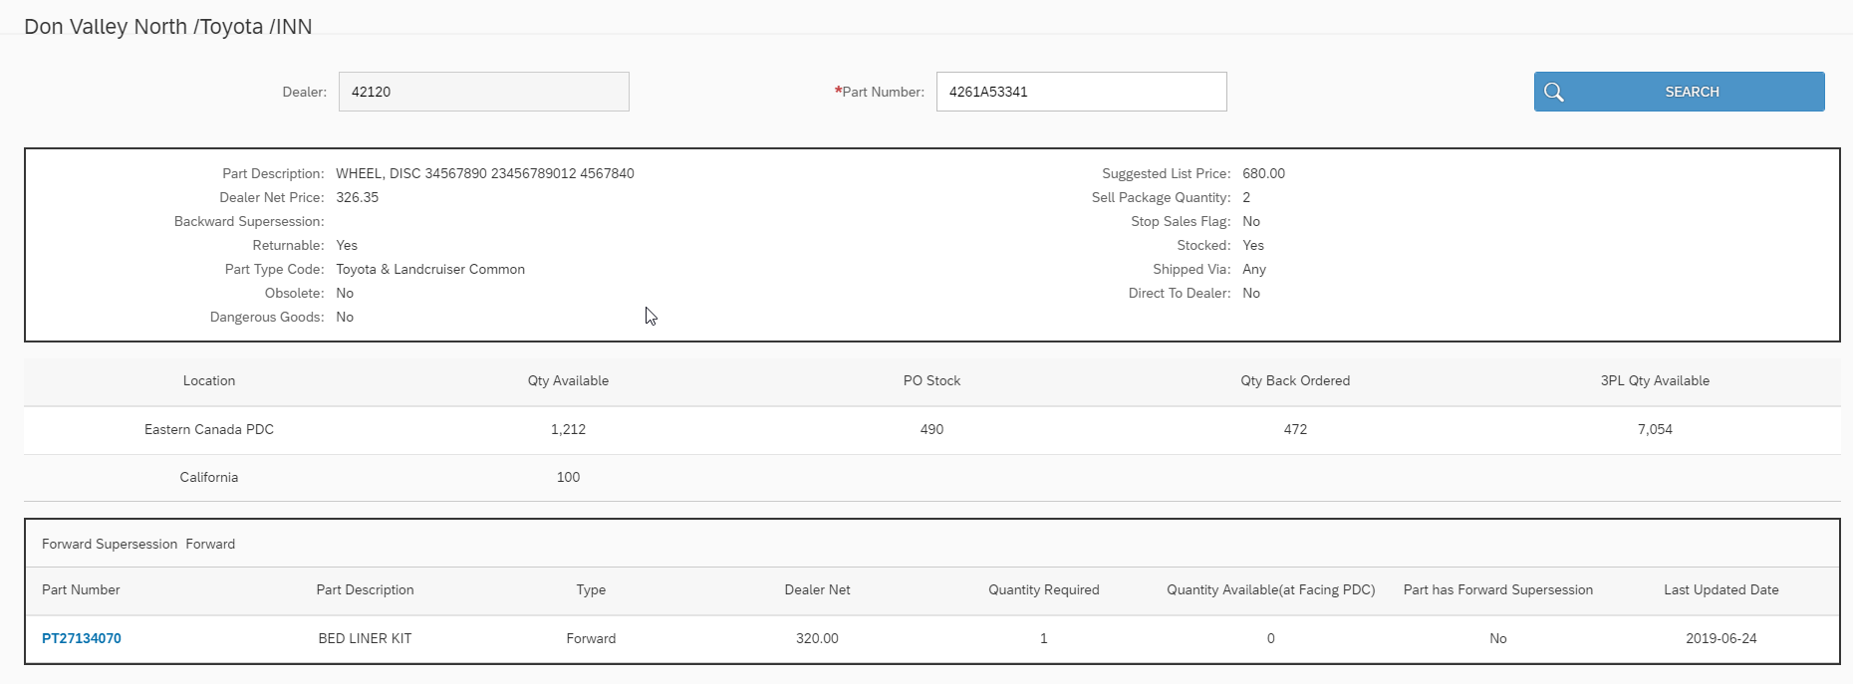

The Division is fetched from the URL and call is made to fetch supplying plant.

oApiBusinessPartner.read("/A_Customer('" + selectedCustomer + "')" + "/to_CustomerSalesArea(Customer='" + selectedCustomer +
"',SalesOrganization='7000',DistributionChannel='10',Division='" + this.sDivision + "')", {
urlParameters: {
"$select": "SupplyingPlant"
},

And then call the priceset service:

var priceSetUrl = "(Customer=" + "'" + (selectedCustomer) + "'," + "DisChannel" + "='" + "10" + "'," + "Division" + "='" + (this.sDivision) +
"'," + "Matnr" + "='" + (selectedMaterial) + "'," + "SalesDocType" + "='" + "ZAF" + "'," + "SalesOrg" + "='" + "7000" + "'," +
"AddlData" + "=" + true + "," + "LanguageKey" + "='" +
(sCurrentLocale) + "'," + "Plant" + "='" + (supplyingPlant) + "')";

The resulting data will have details on Dangerous goods (yes/No), if the part can be displayed to dealer type (Y/N) etc.,

After the data is fetched for the above call, then a call is made to fetch the Forward and backward supersession details using the URL as below and dynamically passing the details selected from the material and supplying plant.

var urlForBackSuperSet = "(Customer=" + "'" + (selectedCustomer) + "'," + "DisChannel" + "='" + "10" + "'," + "Division" + "='" + (
this.sDivision) +
"'," + "Matnr" + "='" + (selectedMaterial) + "'," +
"SalesDocType" + "='" + "ZAF" + "'," + "SalesOrg" + "='" + "7000" + "'," + "LanguageKey" + "='" + (sCurrentLocale) + "'," +
"Plant" + "='" + (supplyingPlant) + "')";
var that = this;
oZMaterialDisplayModel.read("/zc_BackSuperSet" + urlForBackSuperSet, {
urlParameters: {
"$expand": "toForwSuper"
},

After validating the data the model for super session is built (superSessionModel) and bound to the view.

View Controllers Details

The corresponding controller for the view is searchMaterialDisplay.controller. This has the Javascript code for all the functionality as requested in the requirement document.

Suggestion Details:
The Material call is made with filter for material startswith and the sTerm the user provided on the screen,

"$filter": "startswith(Material," + "'" + (sTerm) + "')"

The returned data is bound to the control after validating against the locale (en / fr).

Fragments Details
No Fragments are created for this Application.

Component JS Details
- Loads manifest
- Initializes UI Components for application
- Initializes app router
- Initializes i18n resource bundle
- Handles session expiry dialog for the application

Formatters Details
- Model -> formatter.js has the code to support the quantity and price details.

Patterns Details

ODATA-Gateway (Back-end)
- Main oData Service: ZMD_PRODUCT_FS_V2_SRV
- List of Entity Sets:

Entity set | Filters/key/order | Response | OP
zc_QuantitySet | Matnr eq ‘xxxxxxxxxxxxx‘ | - Location: "A"  - Matnr: "4261A53341"  - QtyAvailable: "100"  - QtyBackorder: "20" | R
zc_BackSuperSet | Customer='2400042120',  DisChannel='10',  Division='10',  Matnr='4261A53341',  SalesDocType='ZAF',  SalesOrg='7000',  LanguageKey='EN',  Plant='7300' | - Customer: ""  - DealerNet: "0.00"  - DisChannel: ""  - Division: ""  - HasForwSuper: ""  - LanguageKey: ""  - LastUpdDate: null  - Matnr: ""  - MatnrSuper: ""  - PartDesc: ""  - Picpos: "0000"  - Plant: ""  - QtyAvail: "0.000"  - QtyReqd: "0.000"  - SalesDocType: ""  - SalesOrg: ""  - ValidFrom: null  - Customer: "2400042120"  - DisChannel: "10"  - Division: "10"  - LanguageKey: "EN"  - Matnr: "4261A53341"  - Plant: "7300"  - SalesDocType: "ZAF"  - SalesOrg: "7000"  - Type: "" | R
toForwSuper |  | - Customer: "2400042120"  - DealerNet: "320.00"  - DisChannel: "10"  - Division: "10"  - HasForwSuper: "No"  - LanguageKey: "EN"  - LastUpdDate: null  - Matnr: "4261A53341"  - MatnrSuper: "PT27134070"  - PartDesc: "BED LINER KIT"  - Picpos: "0002"  - Plant: "7300"  - QtyAvail: "0.000"  - QtyReqd: "1.000"  - SalesDocType: "ZAF"  - SalesOrg: "7000"  - Type: "F" | R
zc_PriceSet | Customer='2400042120',  DisChannel='10',  Division='10',  Matnr='4261A53341',  SalesDocType='ZAF',  SalesOrg='7000',  AddlData=true,  LanguageKey='EN',  Plant='7300' | - AddlData: true  - Customer: "2400042120"  - DisChannel: "10"  - Division: "10"  Item:  - AddlData: false  - Addldata: true  - Bonba: "0.00"  - Cmpre: "0.00"  - Customer: "2400042120"  - Dealernet: "326.35"  - Dgind: "No"  - DisChannel: "10"  - Division: "10"  - DoNotDisp: ""  - Fobprice: "223.75"  - Itmcatgrp: "NORM"  - Kmein: "EA"  - Kpein: "1"  - Kposn: "000001"  - Landedcost: "223.75"  - LanguageKey: ""  - Languagekey: "EN"  - MatGrp: "16"  - MatGrpDesc: ""  - MatGrpDesc60: "GLASS, AUTO, BENT, TEMPERED IN BOXES"  - Matnr: "4261A53341"  - Mgame: "1.000"  - Msrp: "680.00"  - Mwsbp: "0.00"  - Netpr: "331.460000000"  - Netwr: "331.46"  - Obsolete: "No"  - Onpostock: "490.000"  - PIOInd: ""  - Partreturnable: "Yes"  - PartsDispInd: "TF"  - Partstocked: "Yes"  - Parttypedesc: "Toyota & Landcruiser Common"  - Plant: "7300"  - Plantdesc: "Eastern Canada PDC"  - Preva: "0.00"  - Prsok: true  - Pstyv: "ZAFN"  - Qtyavail: "1212.000"  - Qtybackorder: "472.000"  - Roundingprofile: "0002"  - SalesDocType: "ZAF"  - SalesOrg: "7000"  - ScaledetStatus: ""  - Shippedvia: "Any"  - Stopsalesdesc: "No"  - Totaldiscounts: "0.00"  - Totalehf: "5.11"  - Vrkme: "EA"  - Wavwr: "227.09"  - Werks: ""  - Z3plflag: "X"  - Z3plflagdesc: "Yes"  - Z3plplant: "7100"  - Z3plqtyavail: "7054.000"  - LanguageKey: "EN"  - Matnr: "4261A53341"  - Plant: "7300"  - SalesDocType: "ZAF"  - SalesOrg: "7000"

Data Source consideration
N/A
Field name / Description | Table Field Name | Comments / Calculations / Field Manipulations

Data Validation
N/A

Table Field Name | Validation Rule

Error Handling

  - Error Conditions and Logging

Form and few controls validation using validator -3rd party library

  - Notification

N/A
Error | How error message should be reported | Error Messages | Corrective action

  - Restart / Recovery

N/A

Security Requirements/ Authorization Details

UserDetails →attributes: Fetches Logged in user authorization details -language, zone and usertype also Business partner data and sales data as per provided filters in security layer

UserDetails →currentScopesForUser: Fetched scopes for logged in user as per the mapped groups and roles

Additional Information and attachments

  - Reconciliation Reporting

If a specific report or additional information is required is required for reconciliation

  - Attachments

HANA Artifacts
  - Object List : List out all the HANA artifacts which is required to be created/changed

Object Name | Object Type | Ref. ABAP Object | Object Description | Action | Package | Delivery Units | Comments
 | Calculation View/ Attribute view/ Analytic view/ Table/  DB Procedure |  |  | Create/  Modify

  - DB Procedure Details: Specify the details of DB procedure

Procedure Name:

Parameter Name | Parameter Type | Parameter Data Type | Data Type | Length | Scale
 | IN/OUT

Procedure Logic:

  - DB Objects (View/Table) : Specify the details of DB object structure

View Column | Table Column | SQL Data Type | Dimension | Not Null | Default

Sample View Screenshot:

21. Unit Test Plan
Normal Functionality - test cases that ensure the workflow functions as it should. (e.g. updates fields correctly, processes all records)

Test Condition | Step | Step Description | Test Data | Expected Result | Actual Result | Executed By/Date | Remarks

Exception - special logic or exceptions (e.g. do not process Government Markets customers, only process pre-packs)

Test Condition | Step | Step Description | Test Data | Expected Result | Actual Result | Executed By/Date | Remarks

Error Handling - functionality in case of errors (e.g. Customer not found, Record already exists)

Test Condition | Step | Step Description | Test Data | Expected Result | Actual Result | Executed By/Date | Remarks

